

1st Balsham Scout Group

Group Headquarters: Woodhall Lane, Balsham, Cambs

Scouting in Balsham goes back 100 years

The Cubs and Scouts of the 1st Balsham Scout Group are celebrating the anniversary of the first Scout Troop in the village. The evidence for this comes from a Balsham Review in 1976 in which there was an article giving a short history of Balsham Scouts. The article is reproduced below, together with an early photograph of the scouts from the 1920’s (?), which we think might be that mentioned in the text.

If anyone has any further information, photos or memories, please let us know, we would love to find out more.

Seppe Cassettari, Hon. Treasurer
01223 892390 or email seppe@cassettari.org

BALSHAM SCOUT GROUP – A SHORT HISTORY

Three main factors made the writer interested to know more about the history of Scouting in Balsham; they were (i) The reforming of the Balsham Scout Group (ii) This year being the Cub/Scout Movement Diamond Jubilee year (it was originally formed as Wolf Cubs in 1916) (iii) Cambridgeshire were honoured by an official visit by the Chief Scout, the only other official visit was by Lord Baden Powell before the 1939-45 war. Granta District (comprising ten Scout Groups, of which Balsham is one) were interested in a possible link of the past with the present.

Searching for such a link accidentally began at the Scouts Open Evening last autumn, when Kerry Lambert (a scout from 1914 – 1925) brought a photograph along showing Balsham Scouts performing gymnastics in front of Lord Baden Powell during his visit. Kerry clearly remembered all the scouts on the photograph, many of whom are still living in and around Balsham. There were thirteen scouts in the troop at the time in the early 1920’s. The following are members living in the area shown on the photograph:- Charlie Lambert (Abington); Harry Lambert (Letchworth); Kerry Lambert (Balsham); Arthur Gray (Balsham); John Gray (Haverhill); Tom Osbourn (Linton); Walter Beeton (Huddersfield?); Sid Newman (London?); Bob Diggins (Clare). The remainder, now deceased, were Leslie Beeton, Bill Gabbeday, Charlie Carter and Fred Colville.

The Scout Master at this time was Martin Slater who lived at Grange Farm. He also led the West Wratting Troop. Three and possibly six of the above scouts obtained their King’s Scout awards under his guidance.

In my attempt to find more information at the time of the Chief Scout’s visit, imagine my surprise when one very senior Balsham citizen said he was in the forces, but had been a founder member of the troop in about 1910. The Troop used to meet in the Club Room, which was situated where the Long Thatch cottage garage now stands. A point of interest is that this building is now the store room attached to the Church Institute, which again is housing Scout equipment. From the Club Room the troop moved to the Old Maltings; here they had a shooting range, also gymnastic and boxing equipment.

Kerry Lambert was a scout for eleven years until 1925, and during the First World War, he and five others became Sea Scouts helping the coastguard to patrol the coastline at Osmington, Eastbourne and Blackpool. He maintained contact by assisting Martin Slater for a further two years. It was about 1928 when Martin Slater went to Kenya where he became Chief Scout, later returning to Gt. Britain and renewing his interest with the West Wratting Scouts at their 1937/8 summer camp held at Southwold.

S/Ldr. Thompson became headmaster for Balsham during 1927/8. He led the troop until 1935 when he moved to Fen Drayton, where he still lives in the Old School House. He was followed by the late Leslie Beeton, who was in charge until 1938, when the troop disbanded, many scouts transferring to West Wratting under the guidance of Mr. Moore, presently living in Weston Colville, until they also discontinued owing to World War II.

Leslie Beeton also formed the first Balsham Wolf Cub pack somewhere around 1933, when they held their meetings in the Old Maltings. Mrs. Cyrankowski followed as leader of the pack until they too disbanded during 1939/40 and it was in this period the pack won a Sports Competition Shield, beating all other Cambridgeshire Cub Packs.

We finally arrive at 1976 when, with many memories, three former Balsham Scouts who had been introduced to Lord Baden Powell, were presented to Sir William Gladstone, the present Chief Scout, during his visit to the Abington Camp site. The three forming the link with past and present were Kerry Lambert, Charlie Lambert and John Gray.

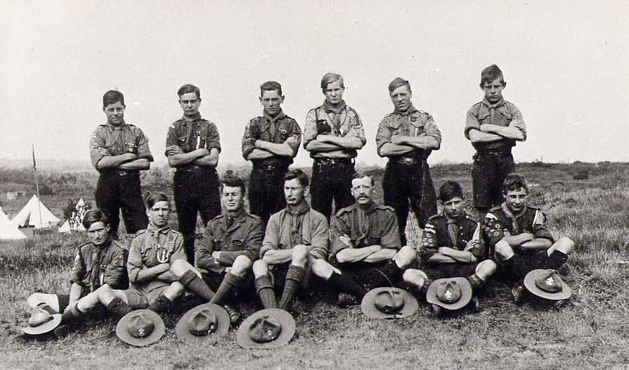

Scouts 100 year anniversary BBQ – all welcome.

To celebrate the early roots of scouting in Balsham, today’s Cubs and Scouts invite anyone interested in the group to join us for a FREE BBQ at the Scout Hut in Woodhall Lane on Saturday 10th July, any time between 4.00 – 7.00pm. Make it a date for your diary – more details to follow.

There will be a display of past records and photos from the Balsham group, examples of the work by current Cubs and Scouts and a chance to see how the hut has been re-vamped over the last 4 years.

It has been commented that the Balsham Scout Group is the ‘one of the best run’ in the District. With over 40 youngsters currently in the Cubs and Scouts and a waiting list of nearly 20, come and see what we do and support us in our commitment to the young people of Balsham and the surrounding villages.

St George’s Day Parade in Balsham

The Balsham Scout Group is delighted to host the 8 groups of the Granta District for their annual St George’s Day parade on Sunday 25th April 2010.

The cubs and scouts will congregate at the Meadow School from 11.00 am and parade to the church for a special service at 12.00, to be followed by a BBQ and activities around the village, ending at about 4.30pm.

This event usually attracts about 150 young people and some 40 leaders and parents.

Balsham Scouts and the district team organising the event will be working with the police to control parking and limit drop-off and pick-up to areas away from the school entrance. We apologise for any inconvenience that might be caused by having so many visitors to the village.

Everyone is welcome to come and see the parade.

Balsham Scouts and Cubs 2010 Fundraiser

Saturday 15th May

8.30am – 11.30am

Mile of Coins
Car Wash at the Black Bull
Cake Stall
Raffle

